Summer-Mae Wall
LL-000023418
Occupational Specialism

Development Log for Greenfield Local Hub (GLH)

Contents

Table of Contents
Development Log for Greenfield Local Hub (GLH) 1
Contents 1
User acceptance Criteria 2
Functional and Non-Functional Requirements 3
Functional Requirements (Business Needs) 4
Non-Functional Requirements (How the system should do things) 6
Key Performance Indicators (KPI) 7
Limitations 8
Scope 8
Versioning 9
Content and Assets Log 9
Images 9
Text 11
Data 13
Version 1 15
Version 1 Development Plan 15
Version 1 Development Documentation 15
What Changed? and Why? 16
Version 1 Evaluation 17
Changes for Version 2 17
Version 2 17
Version 2 Development Plan 17
Version 2 Development Documentation 18
What Changed? and Why? 19
Version 2 Evaluation 19
Changes for Version 3 20
Version 3 20
Version 3 Development Plan 20
Version 3 Development Documentation 21
What Changed? and Why? 22
Version 3 evaluation 22
Changes for version 4 23
Version 4 23
Version 4 Development Plan 23
Version 4 Development Documentation 24
What Changed? and Why? 25
Version 4 evaluation 26
Overall Evaluation 26
Evaluation of Future Development 27
Product categories and search bar 27
User and Staff Settings 27
Password validation 27
Finished Staff System 27
Proper system testing 27

User acceptance Criteria
no. | Criteria | How generated | Why important
1.1  1.2  1.3  1.4  1.5  1.6  1.7  1.8  1.9  2.1  2.2  2.3  2.4  2.5 | Clear navigation bar  Be able to see what products are available and see their ingredients  clear instructions on each page  fast loading times (2-5 seconds max)  alter orders  view orders  be able to select a delivery date and time  clearly see costs  be able to contact customer support easily  automated orders  product organisation  make staff accounts  limit what staff accounts can access  view orders to deliver/ collect | Research through alternative systems (see 12)  restaurant empathy maps (see 6)  following law (see 11) and alternative system research (see 12)  Research through alternative systems (see 12), NFR (see 9)  user stories (see 7)  user groups (see 5)  user stories (see 7)  Research through alternative systems (see 12)  user stories (see 7)  user stories (see 7), empathy maps (see 6)  user stories (see 7), Research through alternative systems (see 12)  user stories (see 7)  user stories (see 7)  empathy maps (see 6), user stories (see 7) | It is important so that users can easily understand and navigate the site.  To check allergens in products, following legislation on food regulations (see 1)  to make it easy for users to understand and reduce stress when using the system  fast loading times are needed to retain customer attention and to ensure the website looks professional  customers may change their mind on what they need to purchase and will want to have the ability to alter their order before it is delivered.  Users need to be able to see what they have ordered and ordered in the past so they can keep track of spending, what works for them, what doesn’t etc.  users need to be able to select a time that works for them for food to be delivered so that they can be there when it arrives.  Users need to be able to see how much products cost so that they can plan and buy products that match their budget  Users need to be able to contact customer support to report any issues they may have. Customers like good customer support that isn’t frustrating to work with.  Users may want the same food delivered on a set schedule (eg businesses). Automated repeat ordering can make this easier on them so they don’t have to waste time placing orders every time.  Products need to be organised in a meaningful way so that users can find them and know what they are purchasing.  Admin staff need to be the only accounts able to make staff accounts so that the system can’t be infiltrated and for UAC 2.4  staff should only be allowed to see data related to complete their jobs in line with GDPR (see 11) to protect the data of users.  It is also important to limit access to reduce confusion when using the staff system  staff need to be able to see who ordered what to package and deliver orders to the correct customer.

Functional and Non-Functional Requirements

Functional Requirements (Business Needs)
1. Customer Needs

no. | Criteria | How generated | Why important
1.1  1.2  1.3  1.4  1.5  1.6 | Users should be able to register and login to the system securely  Users need to be able place an order  Users need to be able to alter and delete orders  Users should be able to view their orders  users should be able to log out of their account  users should be able to view their account details | KPI’s (see 10), risks (see 13)  empathy maps (see 6)  User acceptance criteria (see 8)  user stories (see 7)  Decomposition (see 14)  law/ legislation/ guidelines (see 11) | To prove an increase in account creation (KPI 1.2, see 10), users need to be able to securely make and login to accounts. It needs to be secure to ensure that accounts are not intercepted or created by bots to prevent Denial of service (DOS) attacks.  Users need to be able to place an order for a product for the system to work effectively and sell products.  Users need to be able to add or remove items from their order before it ships out to fit their needs. (families/ households may change their mind on what they want to order)  Users should be able to view their order and its details so that they know what they have ordered and where/ when its coming to check all the information is correct and to verify the order has been placed successfully.  Users need to be able to log out of their account so that forms aren’t resubmitted (causing data to be duplicated in the database) and so accounts are kept secure.  Users need to be able to see their account details so they can be kept up to date. Ensuring the data isn’t redundant/ useless is important for security (passwords etc). It also helps ensure that the system is adhering to GDPR/ DPA 2018 (see 11).

2. Staff Needs

no. | Criteria | How generated | Why important
2.1  2.2  2.3  2.4 | Staff need to be able to login to the system securely  Admin staff need to be able to create accounts and set permissions  Staff need to be able to view orders  Staff need to be able to view and update stock | Risks (see 13)  laws (see 11), risks (see 13), User Stories (see 7)  empathy maps (see 6), risks (see 13), law (see 11)  empathy maps (see 6), risks (see 13), law (see 11) | Users need to be able to securely make and login to accounts. It needs to be secure to ensure that accounts are not intercepted and use to access data on customers (eg address) for malicious purposes.  Only admin staff being able to create staff accounts prevents random people signing up to the staff system and ensures that permissions are correctly set to fit the employees role so that they can only access what they need to for their job (e.g only accessing necessary data on customers to complete work)  Staff need to be able to view orders so that they can be packed correctly. Only staff members in charge of packing orders should be able to see the contents.  Staff in charge of keeping stock need to be able to see what they have received and update the system accordingly so that users can purchase it. Only users who should be updating stock should be able to, to prevent malicious misuse of the system so that the system is secure.

3. General Needs

no. | Criteria | How generated | Why important
3.1  3.2 | The website needs to be accessible and easy to navigate  The system needs to display information about each product clearly | Law (see 11), KPI 1.5 (see 10)  law (see 11), food standards (see 1), User stories (see 7) | The system needs to be accessible to all users under the equality act (see 11). It is best done by following WCAG guidelines to ensure that all users are considered. It is also important to retain customers as they will not become frustrated with the system and are more likely to choose it again.  The system needs to clearly state what a product is and its ingredients so customers are properly informed on what they are buying (protecting their right under the consumer rights act (see 11)), ensuring all products information and standards are up to date with food standards (see 1) and so customers are kept happy because they have received what they wanted when ordering.

Non-Functional Requirements (How the system should do things)
1. User Needs

no. | Criteria | How generated | Why important
1.1  1.2 | System needs to be easy to use  system should be able to run on a portable device | Research through alternative systems (see 12)  empathy maps (see 6) | The system needs to be understandable and easy to use so users choose it over alternative providers  system needs to be able to run on portable devices for staff who are delivering products (remote access) and users who are using the system on a portable device (ordering via a phone) as is the current norm

2. General Needs

no. | Criteria | How generated | Why important
2.1  2.2  2.3  2.4 | Passwords need to be hashed using sha256  Pages need to load in 2-5 seconds max  system should be adaptive to change.  system should have proper encryption when transporting data | Risks (see 13)  Research through alternative systems (see 12), UAC (see 8)  laws/ legislation/ guidelines (see 11), risks (see 13)  laws/ legislation/ guidelines (see 11), risks (see 13) | Passwords need to be hashed with an up to date hashing method (sha256) so that passwords are stored securely in the database  Pages need need to load in a timely matter to retain customer attention and ensure the website looks professional.  The system needs to be adaptable to changes in legislation and to meet the clients needs in the future. The system not being upgradeable makes it less efficient and unsuitable for long term usage.  The system needs to be secure, especially when handling data as per GDPR and to sustain trust with customers that their information is being stored securely.

Key Performance Indicators (KPI)

no. | Criteria | How generated | Why important
1.1  1.2  1.3  1.4  1.5  1.6  1.7  1.8 | Rise in sales  Increased User Account creation  increased orders  increased customer referrals  increased amount of repeat visitors/ customers  less security issues/breaches  increase in staff morale  loyalty rewards being claimed and used | Reviewing sales data  checking audit logs, seeing more accounts being added  reviewing sales data, checking audit logs, stock decreasing at a faster rate  referral programs, KPI 1.2  audit logs, KPI 1.3  risks (see 13)  staff feedback, amount of work done, staff retention  reviewing loyalty scheme data, user stories (see 7) | Seeing a rise in sales is crucial in rating the success of a new system because it shows that it is profitable.  An increase in account creation shows interest and use in the system by the consumer.  An increase in orders means an increase in sales, which proves that the system is profitable  customers referring each other to use the system proves that it is easy to use and like by consumers  customers returning to view and order more products. Shows trust and loyalty with the company and system being built.  Shows the system is up to date and secure to reduce the chances of a breach into the system. Keeping data secure as GDPR states (see 11)  staff’s happiness is crucial to a business. Happy staff work more efficiently and quickly to a high quality.  It also improves staff retention as unhappy staff leave to work elsewhere.  People claiming their loyalty rewards proves that they are using the system and are ordering repeatedly. This shows the system keeps customers engaged and loyal to the service.

Limitations
Due to the limitations of the dev environment I have access to for this task. Some things will be done differently then they would be done in a professional environment.
I will being using echo to output the HTML to ensure that it all runs as intended. This guarantees that all HTML is printed out and displayed to the user. Preventing any issues that could be caused.
For password hashing, I will be using the default hash that comes with the system. In a real development environment I would use more secure and up to date encryptions (eg bcrypt, argon2).
I will also not be encoding the username and password for the database connection, or emails stored in the database.. In a real development environment, these would be hashed/ encoded for security reasons.

Scope
For the scope of this project, I will be focusing on the user order system that allows them to place orders, manage their accounts and view products. This will ensure that it is built to the highest quality and standards available with the time constraints I have.
This means, that I will be missing out on other important factors for building an order system. e.g financials (payments, storing card details securely etc), marketing the system, authenticating logins via a text, email etc.
In a Real Life scenario the project would have a team of people working on the solution. This means that the scope is realistic as different people would focus on the areas of code that they are best at producing. This ensures that the code is produced to the highest quality and in a timely manner to fir a pre-decided time frame that would be agreed upon with the client.

Versioning
For my prototype, I will developing the code in versions. Allowing for code to developed in an orderly and neat manner. This makes the code neater, easier to understand and allows me to go back, return systems to how they were in cases of code breaking, seeing what has been added in each version etc.

Content and Assets Log
In a real development environment, a client may be asked to provide assets to populate the system (for products, images, text etc) to fit their needs. As I have not been given any assets I have had to generate my own. All the assets I have used are temporary and to be replaced with different assets before the site is made live and useable.

Images
All images used in the system are stock images that are designed to be replaced with verified images from the client when real products are added to the system (see product data). All images were taken off of google.
The only exception to this rule is the basket icon which is a free to use icon and does not have to be replaced in post if the client chooses.
I chose to use stock images rather then ai generating images that can be used on a finished website due to legal issues with getting copyrights on said images since they were made with ai and copyright laws dictate that human made work can be copyrighted (ai images may be able to get copyrighted but it may lead to an expensive legal battle to make it happen).
Ai generated images are also not too popular with consumers and may damages the clients brand image if ai images are used over man made images. The news article below shares how most consumers want transparency and that ai imagery means that products could be fake and misleading to a customer. Large companies like coca-cola have received backlash from using ai generated images so to prevent unnecessary backlash that could reduce sales and trust with customers. I chose not to use ai generated images.

Source: https://www.cxnetwork.com/artificial-intelligence/interviews/ai-generated-images-customer-trust-advertising

Images used:
I tried to not use that many images during development so that less has to be replaced when changing all the images over. The images are displayed as an image gallery below.
Please forgive the image placement as there were some issues dealing with such a large amount of images in one spot.
Please View the image gallery below:
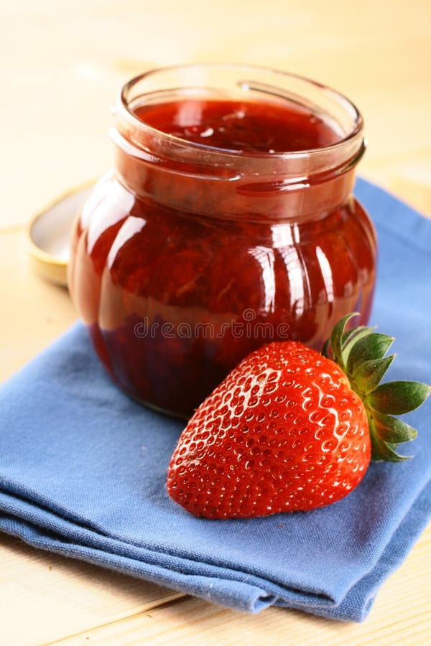
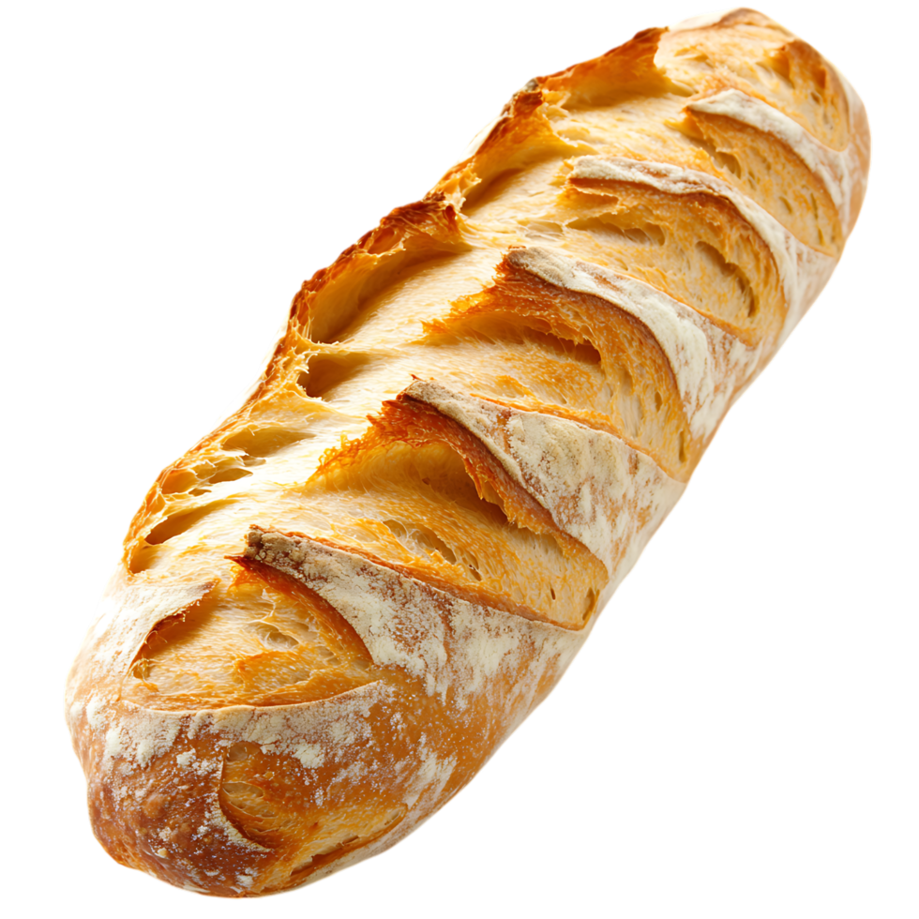


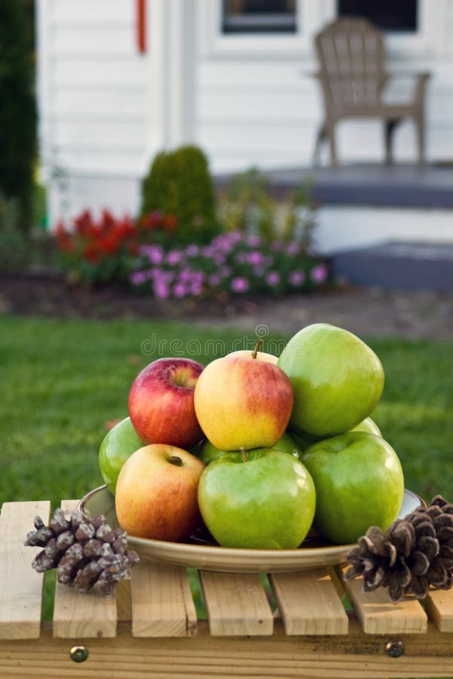


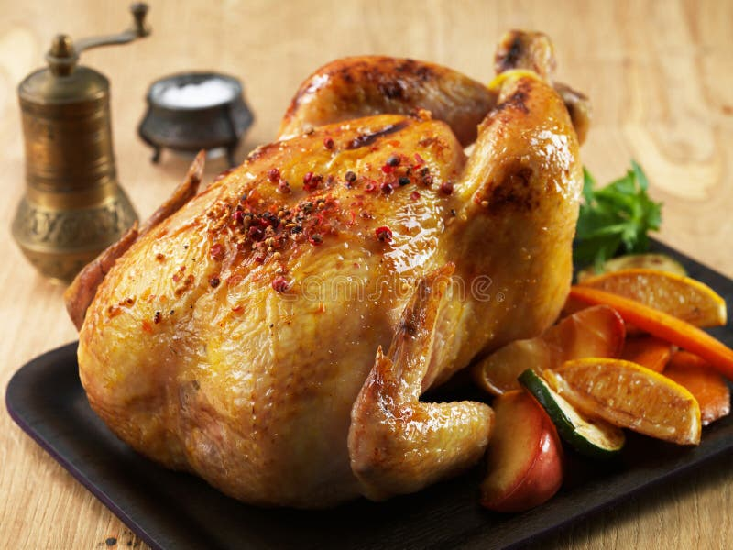



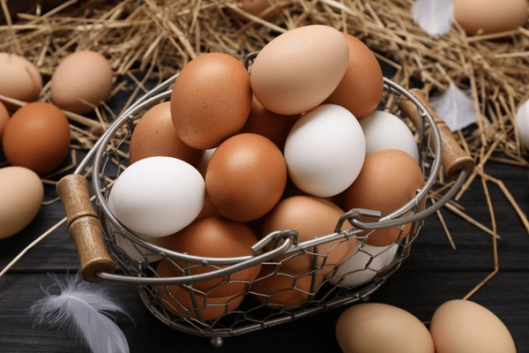


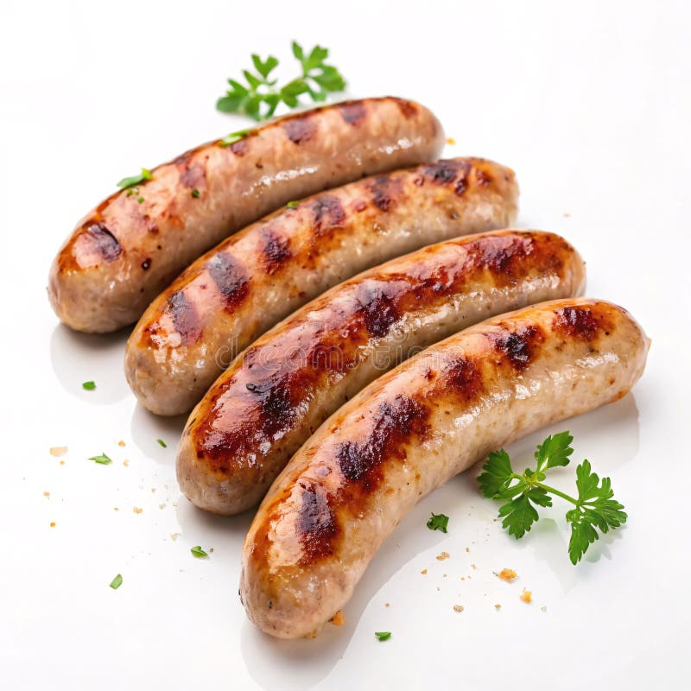



Text
Instead of using ai tools, or writing my own text in. I used lorem ipsum to generate filler text in place of real text. The text is used to help simulate what the finished website may look like when it completed and has real meaningful text that has been verified and approved by the client.
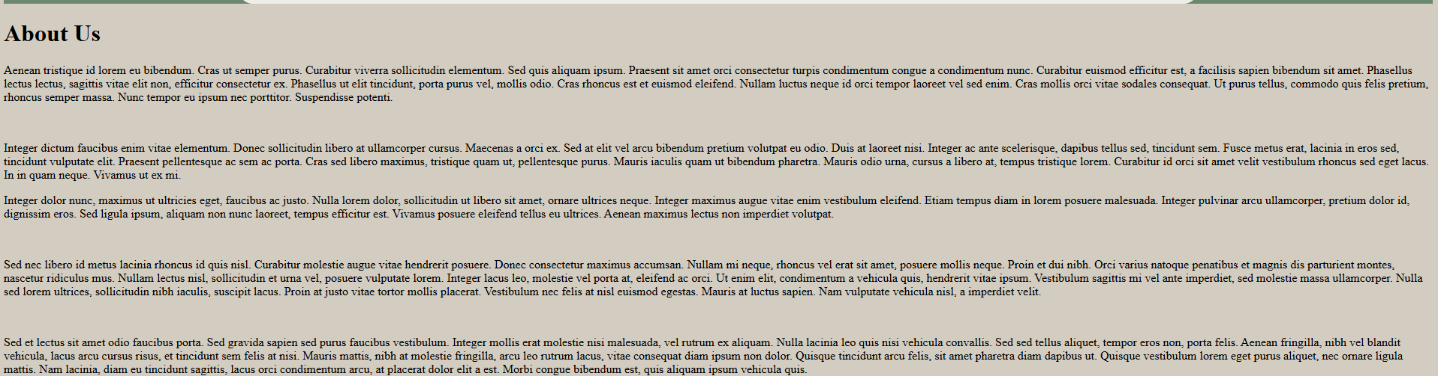
When the client evaluates the prototype they can see and agree on the format of the website before putting real data in so it can be changed later if need be. (image is low quality so check about page to see the lorem ipsum)
The only case in which ai was used to generate text was to create a basic loyalty system format which is quite common to design the loyalty system around. This would of also been given to me from the client in a real development environment.
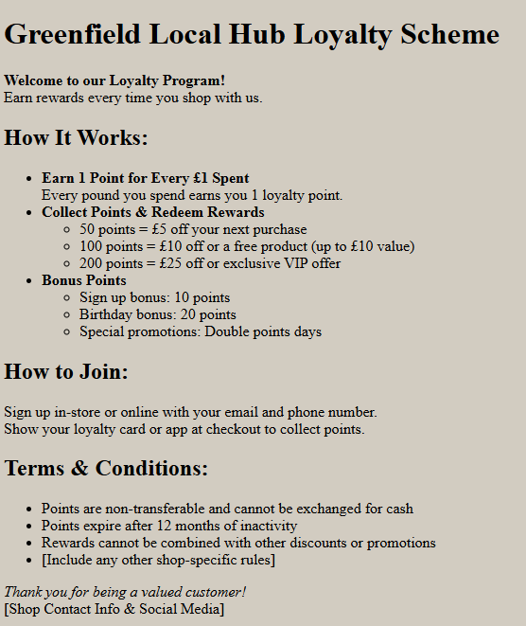

Data
Product data
For product data I used data from my design pack to make fake products to test with. This data is only temporary and should be replaced with real product data later on. In a real ready system, there would also be a lot more data that may be separated into categories (see future development for more details).
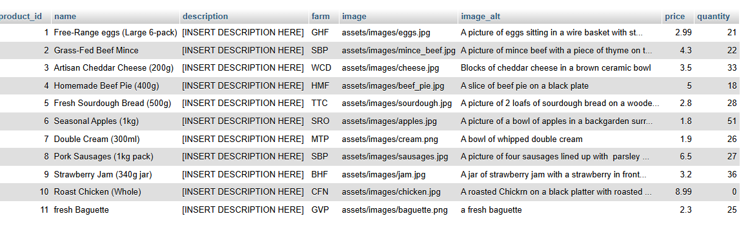

Farm Data
For farm data I used data from my design pack to make fake farm names to test with. Before the website is officially published. These should be updated with real farm names and codes that corresponds to products each farm produces.
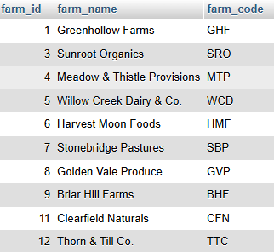

Version 1

Version 1 Development Plan

no. | What is Needed? | Why Needed? | Why Important?
1.1  1.2  1.3  1.4 | Back-end Database  User Registration  User Login  User Logout | A back-end database is needed because all further development will require it.  User registration is needed so users can create accounts to get into the system.  Users need to be able to login to the system so that they can interact with the system (eg manage account details, order etc).  Users need to be able to logout of their account so that the session can end, and to keep the system secure | A secure back-end database is crucial for storing data about users, products etc  Users need to be able to register to the system to use it correctly (FR 1.1). It also helps show the systems performance (KPI 1.2)  Users need to be able to login to the ysstem securely so that they can interact and order products (FR 1.1)  Users being able to logout is an essential feature the system needs to do to keep it secure. It also meets a customers needs as they will want to logout (FR 1.5) once they have finished on the system (especially if they have logged in on a public device eg library computer).

Version 1 Development Documentation
1.1 Back-end database
to start off I built my database based on the design made in the design pack. Making all the tables to meet what was designed. (tables displayed below, please see sql export for table structure)
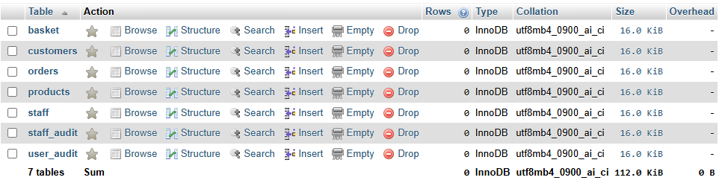
For adding data to the database, I chose to make individual user accounts for each action (inset, select, update, delete). This means that in the case someone breaches the system through the database connection, they cant do anything with it. Update and delete have more permissions as they need those permissions to function correctly.
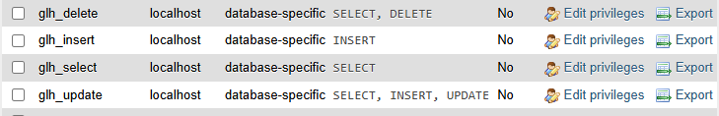
1.2 User Registration
For the user registration, I made a system that checks to see if the account already exists with a function “email_ver()”. When the system brought back that the email did not already exist within the system, It ran a second function “reg_user()” which inserted the data the user inputted into the database.
1.3 User Login
For user login, I used a function “login()” to interact with the database, which selects a users id number and password from the email, the user inputted. This can then be used to confirm the password is correct and that the correct user account is selected.
1.4 User Logout
For user logout, I simply ended the session in which they are logged in, making the user logout. This is displayed to the user with a user message for accessibility and to prevent the user from getting confused.
1.5 Other
Whilst doing css, I decided to change the background colour from #eeeee9 as it displays in the design to #d3ccc0 as it is a bit easier on the eyes and makes the page look more clear. #eeeee9 will be repurposed as an accent colour for the footer (copyright). CSS will be further developed in version 3.
I also added the header and footer to improve the system general appearance and so they can be added into all the pages that are being made initially. This saves time later on.

What Changed? and Why?
Unlike my plans, I spent time building a functional Navigation bar (UAC 1.1) that changes when a user is logged in vs being logged out. This allows for logged in users to access pages that logged out users cant (eg managing account, ordering/ viewing orders etc). I also spent more time adding css to the page to make it easier on the eyes during development and so that the system can be developed to look like the design.
Some fields in the database changed their data type from the designs to ones I thought were better suited.

Version 1 Evaluation
I started this version by building the whole planned database so it set up for later versions. Preventing having to edit it later on. This means the changes made in the database can also focus on data changes throughout future versions.

Changes for Version 2
For version 2, I plan to start building the e-commerce system that allows users to add items to a basket, allow users to select whether the order is for collection or delivery and complete the order successfully. Users should then be able to view their orders.
I also intend to add the audit system that logs what users do on the system for security. Users should also be able to view their audit logs under GDPR/DPA regulations.

Version 2

Version 2 Development Plan
no. | What is Needed? | Why Needed? | Why Important?
2.1  2.2  2.3  2.4  2.5 | Audit System  Product Display  Basket  Checkout  view orders | An audit system is needed to log what users are doing in the system.  Products need to be displayed to the user from the database so that they can browse products and learn information about it.  A basket is needed so users can add items to the basket to stored until an order is completed. | Its important to have an audit system to evidence and log what a user is doing. In cases of malicious activity. It is logged to be used as evidence and to help find where people might have been able to breach into the system etc.  Products need to be displayed in a meaningful way so users can be informed on products, what they are, what they contain etc. (UAC 1.2)  Users need to be able to keep track of what they are planning to buy and a basket helps them do that.  Users need to be able to checkout their orders for the system to be profitable (KPI 1.3).  Users need to be able to view their orders so that they can keep track of what they have ordered and canel/ alter them if need be.

Version 2 Development Documentation
2.1 Audit System
For the Audit system, I added audits for when a user creates, logs in or out of an account it is logged in the system for security purposes.
It also audits when a user adds, removes or updates the quantity of items in the basket and completes order. This is important because it logs what a user has done during the ordering process so it can be proven if a user complains about additional or missing items in their order. It can help GLH determine fault in that or other situations.
An audit system helps us keep track of what users are doing whilst interacting with the system. It is important to know what users are interacting with, especially when it comes to the back-end database that stores important data. In a situation of any form of breach into the system, especially the database, it can tell us what that user was doing to get into the system and which user was using the system at the time of the attack.
2.2 Product Display
For product display, I used functions to pull product information and display in a meaningful way on the products page, with the ability to click on a product to get more details about it.
If I had more time to work on it, I would put more products in the database and give them categories and only allow them to show up with their categories.
2.3 Basket
For the basket, the products are stored inside the session super global until an order is completed. This prevents basket contents from having to be stored in the database whilst users browse (having to be inserted, removed and altered as users shop). Reducing the amount of database connections that could become vulnerable to a breach.
It also reduces load times (UAC 1.4) as the system will not have to send and retrieve data from the database every time a user adds an item to basket.
It also allows users to fill baskets for later orders in any situation where the database is down for whatever reason, keeping the system running as smoothly as possible in emergency situations.
2.4 Checkout
For checkout, a user inputs whether they want the order for collection or delivery and the date for collection/ delivery before submitting the form (UAC 1.7).
On a successful order, the order details (col/del, dates etc) are stored in the orders table, whilst the items ordered are stored in a separate basket table. Ensures that users can order as many items as required without bloating up the order table. It will also help in the future development of the staff side of the system as it will allow staff to see what data they need to see easier with less complicated database connections. ( a simple database connection that is easier to understand, is easier to keep secure)
2.5 View Orders
view orders will be moved to version 3.
2.6 Other
Although it is not currently functional and needs fixing, I have made a start to a stock management system. I felt it was important to set up the groundwork of the stock management system, whilst developing the order system to save time implementing it into the system later on.

Product pages, I ensured that users can select products to be brought to a single product page. It works by storing the items id in the url and using it to select the correct items details from the database to display. This allows users to see product information (FR 3.2, UAC 1.2). For example, what farm a product is from, product description etc.
I also ensured on the wider range product page and the single product page that the price was clear and easy to understand. Making sure that the user was informed on the price of products (UAC 1.8).

What Changed? and Why?
I didn’t end up including the ability to view orders in version 2 because the other features on version 2 took longer then expected to develop. There was more features that needed implementing then I originally thought eg product page display, single product page display.

Version 2 Evaluation
This version did not go as smoothly as I had hoped. I struggled to develop certain features (eg the basket, order system etc) as well as maintain an understandable css to make the product easier to understand.
I did not record enough testing during this version as I had overlooked it whilst working though some of the harder bits of code, leaving some crucial systems under tested, not showing the correct process timeline in my test log/ testing evidence.
If I were to develop this section from scratch, I would of allocated more time to testing and understanding what went wrong and how to improve with the proper logs to back it up so that anyone else coming to work on the system in the future (updating, further development etc) can have a higher understanding of what went on during my development and how I fixed issues in case they encounter the same ones.
I also completely overlooked adding a loyalty scheme into the system during ordering, leaving a gap which I will have to go back and add in version 3. If I had added the loyalty scheme in version 2, whilst developing the order system, It would be better implemented.
The bright side however is that if I accidentality break my order system whilst implementing the loyalty scheme, I can always revert the order system back to my one from version 2.

Changes for Version 3
View order, loyalty scheme, stock management, more testing..
For version 3, I intend to finish the user side of the system. Adding the ability to view, alter and delete orders, the loyalty scheme, fix the stock management system and complete proper testing of all components with normal, erroneous and extreme tests. This will ensure the system is secure and ready for user testing.

Version 3

Version 3 Development Plan
no. | What is Needed? | Why Needed? | Why Important?
3.1  3.2  3.3  3.4 | View, alter and delete orders  loyalty scheme  stock management  system testing | Users need to be able to view when and where their orders are to be delivered, alter them to fit their needs or cancel them for a refund if they have changed their mind or situations change.  A loyalty scheme is a requirement that GLH has set and wants implementing to improve the customer experience and increase the amount of repeat customers (KPI 1.5)  Stock management is needed to ensure that customers products are available and can be ordered successfully.  The system needs to be properly tested to ensure that the system is secure and safe against malicious activity. | It is important that users are informed on their order details (FR 1.4) and to have the ability to alter or delete it after it is completed to meet their needs as a user. (FR 1.3)  The loyalty scheme is important to generate user interest and attention, this will help increase sales (KPI 1.1) and increase the amount of repeat customers (KPI 1.5) and promote customers to refer their family and friends to use GLH for their shopping (KPI 1.4)  Stock management is needed to ensure that the system is up to date with current stock. It can also help generate sales data on each product to help see what customers like to help farmers know what is best to invest time and resources in.  Testing a system is a crucial step in any development to ensure it is easy to use (NFR 1.1), fast and as efficient as possible (NFR 2.2), secure etc.

Version 3 Development Documentation
3.1 View, Alter and Delete Orders
I have made a view system that allows users to see their order details and cancel their orders if they choose. The orders are separated by past and present orders so users can’t try to cancel an already delivered order.
I will not be making the alter system due to a lack of technical knowledge to integrate a system that would allow users to change items in their basket into the system.
Only the cancel order button has any functionality. The other buttons are there for future development, making the system adaptable to change (NFR 2.3).

When a user cancels an order, the order is removed from the order and basket table, the stock for the item is updated to reflect the order being cancelled so stock can be resold and a users loyalty points for the order are removed to prevent users from placing orders and cancelling them to rack up loyalty points.
For future development into a payment system, orders placed using loyalty points should not be able to be cancelled and users should not be able to cancel an order is it means they go below zero in points to prevent users from placing orders for points, placing an order with the points, then cancelling the original order.
3.2 Loyalty Scheme
Due to the scope of my project I will adding functionally to add points on purchase but no functionality on using them as I will not be making a payment system and to use loyalty points, It would take money off of the purchase before purchasing.
I made a basic loyalty scheme that allows users to collect points when they place an order and a registration bonus of 10 loyalty points. It works with 1 point per £1 spent so users will get points per order placed based on how much they spent.
3.3 Stock Management
for stock management, I started by making the stock management system functional and changed it to meet the needs of my system better.
To keep it simple, when an order is placed, the stock is removed from the quantity of the product in the database.
When an order is cancelled, the stock is returned to the quantity in the database so it can resold and wont be lost on every order cancellation.
3.4 System Testing
I did some basic system testing for normal, erroneous and extreme cases of test data to ensure that the system works to a good rigorous standard based on what users may do to try to attack the system/ inputting incorrect data etc.
If I wasn’t bound to the time limits of my exam, I would spend more time on testing and test with fresh eyes on the system and with input from other people to ensure that I didn’t miss anything.

3.5 Other
In version 2, I forgot to add the product add to basket functionality to the single product page, only to the main product page. When added some issues with the arrays when getting products opened up, causing the basket to store the product with the intended products id +1. This was because the array that got the items from the database wasn’t a proper array. This was fixed by placing the database result into a proper associative array.

When a product was sold out, the user could not add it to basket, so to ensure the user received a message and clear communication on why they couldn’t add it to the system, I changed it so when an item is sold out. The button changes to a disabled button displaying “sold out” so users cannot add it to their basket.

What Changed? and Why?
To be transparent, I had forgotten to plan out my loyalty system so that it could be implemented into the main system. This lead to some changes in the database (adding a new table to store loyalty points and storing the order total in the database).
I also changed how my stock system was planned out, the system was planned to have the quantity be a set daily amount, but I decided to change that to where it has to be set my staff on a separate staff system.
Finally during testing some issues were spotted that lead to some changes in how the code worked for registering and logging in to prevent accounts being duplicated and ensuring that logins are secure.

Version 3 evaluation
Version 3 went a bit smoother then version 2 but there were still some bumps in the roads, systems breaking, code not going as planned etc.
I tried to focus more time on updating my test log with up to date tests but I will admit. I am still not happy with the amount of tests I recorded. If I were to start this version again I would try to prioritise tests more then I did. My testing evidence is detailed but it could show the results of other tests in my test log and I regret not numbering my tests in the test log from the start. (see more in my overall evaluation)
I managed to finish the user side of the system to meet the basic requirements that the client has specified. I will now be moving onto building up a staff side system for staff to interact with .

Changes for version 4
For version 4, I want to start the development of the staff side system. Allowing staff to login into accounts and adding some basic functionality to help support the customer side of the system. Due to the time constraints of my exam, I will not be able to build a fully fledged out system.
I had overlooked building a staff system earlier on, and realised during the development the needs it needs to meet to support the user side. (updating stock, adding new products etc)

Version 4
Due to the time constraints and my failure to plan for the staff system, I will be focusing on a basic admin version of the staff system. Excluding delivery drivers, store employees etc. A staff account will be able to access every thing. If I had more time to develop a flushed out staff system, I would ensure that staff can only access pages required for them to do their job.

Version 4 Development Plan
no. | What is Needed? | Why Needed? | Why Important?
4.1  4.2  4.3  4.4 | Staff login system  Registering accounts  updating quantities of products  adding new products to the database. | Staff will need their own side of the system. Completely separate from the users with a secure way of logging in so users cannot try to access the staff portal  Only Admin Staff should have the functionality to register staff accounts (FR 2.2) to protect the system and ensure that only currently employed members of staff have access to the system.  Updating the quantities of items is important so that the system can be kept up to date with the current stock of products. (FR 2.4)  To keep the system up to date with products the farmers are making, the system needs to be updatable with what new products are made later on. | The staff system needs to be secure and only accessible to staff members to ensure that users do not attempt to login and alter what is true in the staff system. (FR 2.1)  It is important that only admins can register staff so that other members of staff cannot register unverified users to the system (eg a family member or friend). It is also important to reduce the amount of access they have to make the system easier to use.  It is important to keep the system updated so that users will always have products to order so that the system is profitable  It is important to allow new products to be added to keep the system up to date and make it adaptable to internal changes (NFR 2.3) made within GLH.

Version 4 Development Documentation
4.1 Staff Login System
For the staff login system, I have saved some time by copy and pasting the user login system and making some changes to the functions, webpage to ensure it works. The system only requires an email and password to login that would be sent to the staff (for future development, the staff system needs a way to change the password since the original will most likely be a generic password set up by the admins.)
During the development, I realised that to test the login system that the register system needs to be created to add an account to test the login system with so that was accomplished.
4.2 Registering Accounts
For registering staff accounts, I have made it so you have to be logged in and have access the correct clearance (admin) to register staff to the system.

The audit system reflects this as when an account is made, the audit will audit the account that registered the new account rather then the account itself like how it is done in the customer side of the system.

4.3 Updating Product Quantities
For updating product quantities, I reused the add stock functionality I already had to speed up the development process and because I knew it worked for what I needed. I also did the game with the product page display to display the products that can have their quantities updated for the same reason.
This significantly sped up the development process and ensured that the code was easy to understand and secure. The code was altered to meet the needs of the page, removing unnecessary things shown in the customer product page like an image and the price.
For future development, I would organise the products into categories and have buttons to show products based on category and a search feature to search for a product to make it faster for staff to update quantities.
4.4 Adding new products
For adding new products, I took inspiration from the registration system and applied it to add new products to the products table. A staff member would have to insert data about the product to add it to the database, which will then be automatically displayed on the product page and be able to be purchased.
With the images, you type in the file name and create an alt tag. An oversight I had whilst designing the page is how the image file is uploaded to the image folder in the assets. For future development, the Image would have to be uploaded to the page and inserted to the images folder through that way. The image file name would be taken into the database how it currently is.
The current system allows just the image name to inputted and then the file path is added by the system to ensure that all the images are stored correctly.

4.5 Other

Logout
During development, I realised I had not considered staff users needing to logout after. I ensured that this base feature was implemented. I originally was going to piggy back it off of the customer logout system but chose to scrap that and implement it separately to ensure the logout was secure, audited correctly and users were sent to the correct place after.

Farms
Whilst developing 4.4 I decided to create a new table to store data about the farms that the products come from. This was implemented and then the data from the farm table was used to allow staff to select a farm to assign to a new product. This reduces mistakes that could be made with the past farm code system.
With the new table, I also used it to update the single products pages by displaying the farm name rather then the farms code.

Page access system
I created a basic page access system for the staff side of the system, ensuring that staff only see links to pages they need access too and that they can’t access other parts of the system if they manage to get on those pages (eg by typing the page name into the url).
I did not have time to fully test this feature however so I cannot confirm its accuracy.

What Changed? and Why?
During development, I had to change my plan to meet factors I had not originally considered (see 4.5 other) like updating and changing the tables to add a farm table which led to me changing how farms are displayed in on the product page.
This version there were the least amount of changes made since I started development on the staff side of the system. A completely separate system to what customers will interact with.

Version 4 evaluation
During this version, I tried to prioritise logging my tests in my test log and testing evidence to a more proper testing manner that I should of upheld throughout development. This helped provide more proof of tests and a deeper understanding of problems and their solution.
I created the start to a staff system during this part of development with the plans for future development to occur (adding more features/ functionality) and built a basic system that allows for products to be added and the quantities of products can be updated as new shipments of products come in.
With the time I had remaining, I tried to develop the start of the staff system and purposely built features that helps sustain and make the customer system useable so that orders can be made.

Overall Evaluation
During the development of my system, I built a functional customer system that allows users to register and login to the system to order products for collection or delivery. The system checks to make sure that accounts can’t be duplicated and that passwords match correctly. The passwords are hashed and stored securely in the system.
Users can select items to purchase which are stored in a basket (stored in session) that can have items removed or the quantity of an item changed before checking out. Where a user would select collection or delivery and a time for pickup/ delivery.
After an order is completed, a user can view their orders and choose to cancel one, given it is before the delivery date has arrived.
There is also a stock management system, that allows stock to be updated when a user orders products or when they cancel an order. I did not fully test this however to handle the stress of multiple users taking the stock at once and am unsure on how it would react if a user managed to try and order stock that isn’t available.

However before I started development, I will admit my system was poorly planned out. I jumped straight into coding too fast before sorting out important details like my testing table and evidence which effected me throughout development as my testing, specifically my testing evidence, was not done to a good thorough standard. I missed testing features like double bookings, booking into the far far future etc.
If I were to start this project again, I would try to prioritise testing and spend more time testing and perfecting each section before moving on.

With my Product system, I also regret not setting up product categories from the beginning and leaving them without. This wouldn’t of just help set up the product page and make it more organised and easier for users to navigate but it would of helped make updating the quantities of products easier in the staff side system too since they could of more organised then just a big line of them.
Not organising the categories also leaves the product system looking unprofessional and unfinished. The system currently will not be able to handle displaying the large amount of products the client expected it to be able to handle.
Finally, I completely forgot to document my contents/ assets until the very end which left their analysis rushed and not up to my usual standard.
If I were to start this project again, I would of read more carefully what was expected of me to document during my development so I could have a more detailed explanation on why I chose certain images, choices for content etc.

Evaluation of Future Development
If I were to develop this project further, I would implement and update some of the following features.

Product categories and search bar
As mentioned in my Overall evaluation, I would implement product categories that would allow a user to browse products based on the category so they can fully see what products there are to offer and they don’t have to see the products they don’t want too (eg if someone who doesn’t eat meat or fish do not like to look at it, they wouldn’t have too).
I would also implement a search bar so users can search for specific products which can help them find them a lot faster then if they were to search through the categories. This would help improve staff efficiency on the staff side and reduce customers becoming frustrated when they can’t find products they want to buy.
It would make the customer and staff system easier to use as well as look and feel much more professional.

User and Staff Settings
I would also implement Proper account settings for users and staff allowing them to properly manage their accounts to meet their needs.
Customers
Customers would have more freedom over their accounts. Having full control to change their email or password, to request and view data stored about them in the database (required under the data protection act) and the ability to delete their account if they choose too.

Staff
Staff would need to have their account settings managed by admin staff with them having to talk to staff about password changes, account removal (if they leave the company etc)

Password validation
The register system for all users does not contain any proper form of password validation beyond confirming it is correct. This means that users can make their password anything they want, with whatever characters they want. This can leave a large amount of user accounts susceptible to being hacked and taken over as passwords will be easy to guess.
Proper password validation would prevent this by ensuring that users have a special character, number, capital letter etc to make their passwords harder to guess.

Finished Staff System
The staff system is not finished. I did not have time to add the ability for staff to view orders for packing or delivery.
I would ensure that staff can see order contents (baskets) and whether an order is for collection or delivery so that when they are packed they can be organised into the correct categories. (ensuring that a collection delivery isn’t accidentality sent to delivery and vice versa. It would be important that staff cannot see a users details for just packing an order.
Staff should only be able to see customer details during delivery (addresses) or for collection (confirming that they hand the order to the right person) so this would be handled separately from what staff can see whilst packing orders to protect customers data.

Proper system testing
I would ensure that proper testing of the system occurred. Testing different browsers. 2 or more users ordering at the same time (eg if someone orders the last product whilst its in someone’s basket) and ensuring that the system is secure and cannot be breached or manipulated to do something it is not designed for.

